Mobile Financial Services (MFS) TV Advertising Campaign Analysis
Media Efficiency, Competitive Positioning & Strategic Insights

This project presents a strategic analysis of the Mobile Financial Services (MFS) advertising landscape in Bangladesh, focusing on television advertising performance, media investment efficiency, campaign continuity, and competitive positioning.

1. Executive Summary
This project presents a strategic analysis of the Mobile Financial Services (MFS) television advertising landscape. The study evaluates how leading MFS brands utilize television advertising to build brand visibility, maintain consumer attention, and improve media investment efficiency.
The analysis focuses on Share of Spend (SOS%), Share of Voice (SOV%), Media Efficiency Index, campaign continuity, message strategy, advertising timing, and competitive positioning. The objective is to transform advertising performance data into actionable marketing insights.

2. Project Background
Television remains an important mass communication channel for building awareness, trust, and digital adoption in the MFS industry.
This project analyzes broadcast advertising patterns from January 2025 to April 2026 and evaluates competitive media strategies among major MFS players.

3. Research Objectives
- Measure advertising efficiency by comparing investment share and visibility share.
- Understand how brands use continuous campaigns versus seasonal advertising bursts.
- Analyze communication themes and strategic positioning.
- Identify market opportunities and improvement areas.

4. Analytical Framework
The project evaluates campaign performance using the following metrics:

Metric | Purpose
Share of Spend (SOS%) | Measures advertising investment contribution.
Share of Voice (SOV%) | Measures advertising visibility and presence.
Media Efficiency Index | Calculates SOV divided by SOS to evaluate efficiency.
Campaign Flighting | Analyzes continuous presence versus tactical bursts.

5. Key Findings

Media Investment vs Visibility Performance
The analysis demonstrates that higher advertising spending does not automatically guarantee higher visibility. Efficient media strategies create stronger Share of Voice compared with investment level.
The market leader achieved a Media Efficiency Index above 1, indicating that visibility exceeded spending contribution.

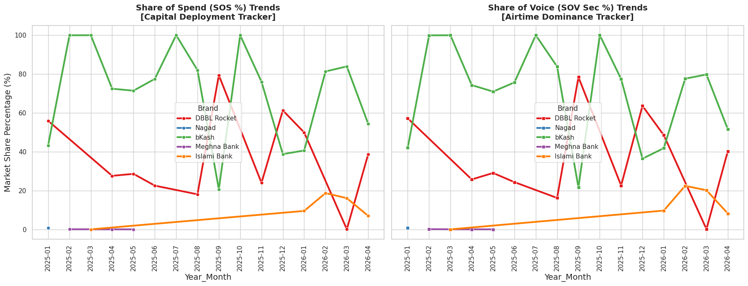

Figure: Tracking Monthly SOS% vs. SOV% across the MFS Category (Jan 2025 – Apr 2026)
Always-On Media Strategy
The analysis identifies two different approaches. The leading brand maintained consistent media presence across periods, while challengers relied more on concentrated seasonal campaigns.
Continuous advertising helps strengthen brand recall and protects consumer relationships.

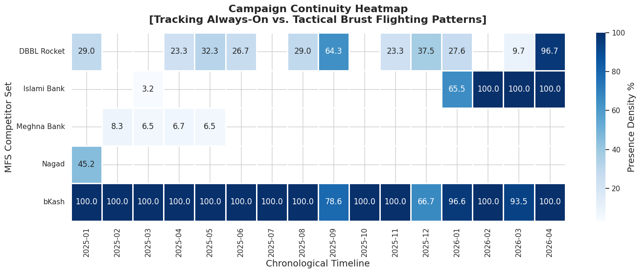
Figure: Mapping Brand Presence Density (% of Days Active Per Month) to Expose Media Handbooks.
Communication Strategy Analysis
Leading communication strategies focused on ecosystem development, app adoption, utility services, and consumer lifestyle integration. Competitors focused more heavily on promotional and price-driven messages.
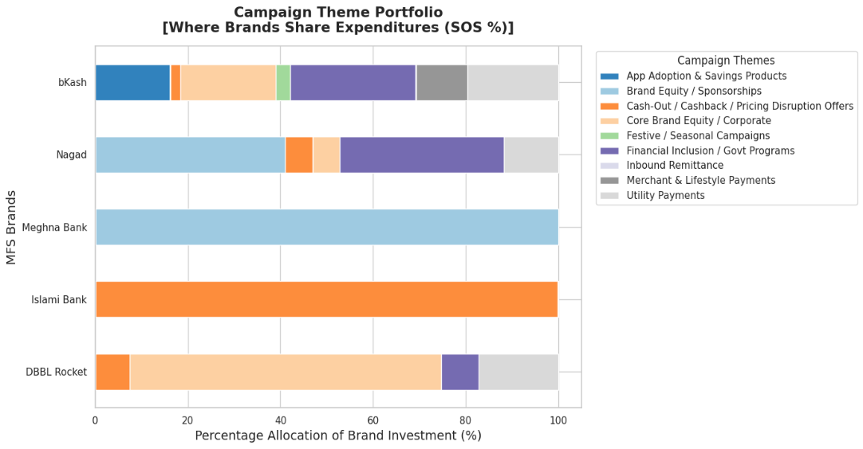
Advertising Timing Strategy
The analysis shows that balanced daypart allocation can improve reach and frequency efficiency.
Heavy dependence on expensive prime-time slots may increase cost without proportional visibility gains.
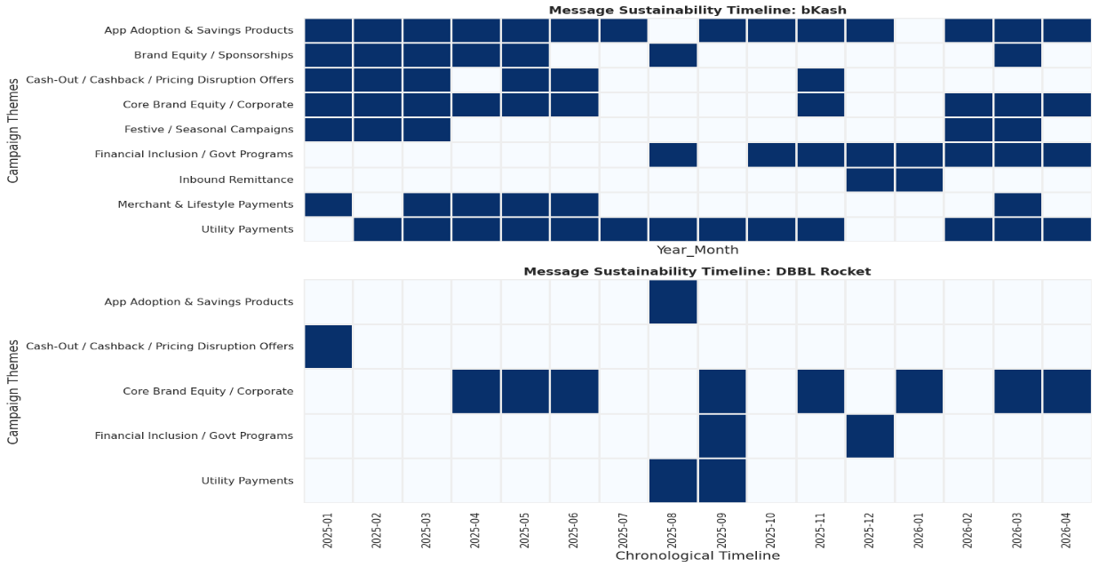
Figure: Analyzing Chronological Campaign Lifespans to Separate Long-Term Strategy from Tactics
Media Efficiency ROI
Maximizing Share of Voice per Taka Expended for each brand.

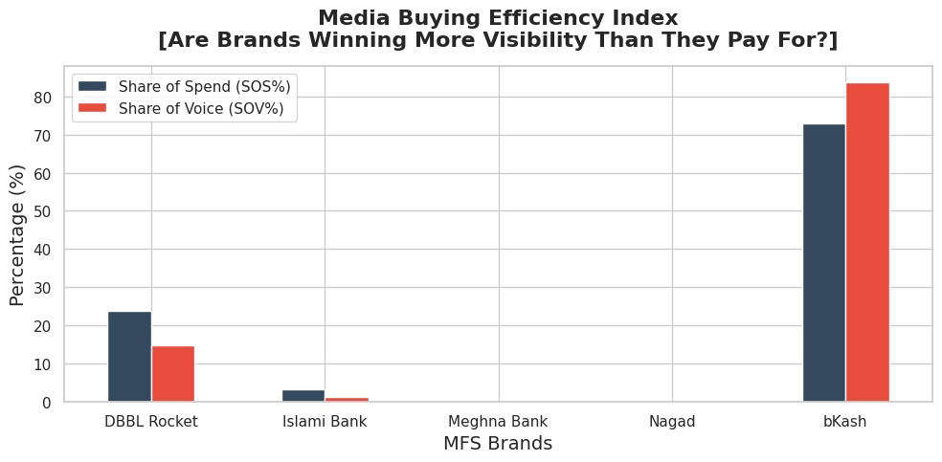
Figure: Evaluating the Strategic Spread Between Category Share of Spend (SOS%) and Share of Voice (SOV%)
6. Market Opportunity Analysis
The project identified two important whitespace opportunities:
1. Small Merchant & B2B Growth:
MFS brands can strengthen communication with small businesses, retailers, and entrepreneurs by highlighting merchant payment ecosystems.
2. Digital Lifestyle Integration:
Brands can position MFS as an everyday lifestyle platform beyond traditional transaction-based communication.

7. Strategic Recommendations
Maintain Always-On Presence
Develop continuous advertising visibility instead of depending only on seasonal campaigns.

Avoid Price Competition
Focus communication on ecosystem value, trust, and differentiated services.

Optimize Advertisement Formats
Use longer storytelling advertisements for engagement and shorter formats for frequency building.

Balance Long-Term and Tactical Investment
Maintain a strong brand foundation while using seasonal campaigns strategically.

8. Methodology & Analytical Approach
- Competitive benchmarking
- Media efficiency evaluation
- Campaign timeline analysis
- Strategic positioning mapping
- Communication portfolio analysis

9. Project Outcomes

This project demonstrates the application of marketing analytics in evaluating advertising effectiveness. It highlights how media data can support strategic decision-making, optimize advertising investment, and improve competitive positioning.

10. Conclusion

The analysis confirms that successful advertising performance depends on more than financial investment. Long-term dominance is achieved through strategic media planning, continuous visibility, effective communication themes, and efficient resource allocation.
This project demonstrates how advertising analytics can convert campaign data into meaningful business recommendations.

